|  |  |  |
| --- | --- | --- |
| **Task** | **Due date** | **Weighting** |
| **Creative writing** | **Thursday 10th March (Draft)**  **Thursday 17th March** | 20% |

|  |  |
| --- | --- |
| A student | |
| EN4-3B | uses and describes language forms, features and structures of texts appropriate to a range of purposes, audiences and contexts |
| EN4-6C | identifies and explains connections between and among texts |
| EN4-5C | thinks imaginatively, creatively, interpretively and critically about information, ideas and arguments to respond to and compose texts |

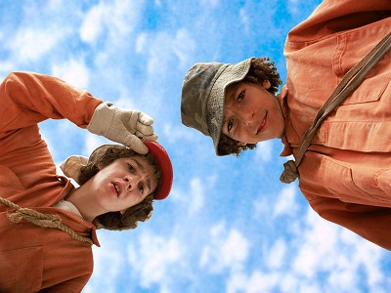

Year 8 English

**In your answer, you will be assessed on how well you:**

* Reflect a solid and complete understanding the genre and style you have studied
* 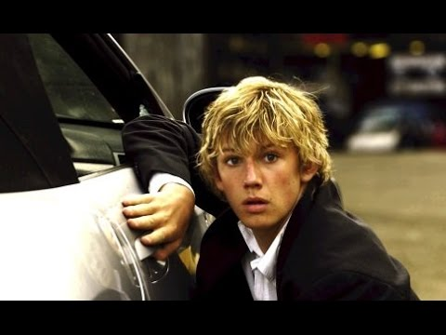Create and sustain an interesting central character
* Structure your story as a complete narrative
* Write with detailed attention to spelling, grammar, punctuation and form

**I want to be *just* like you!**

**Creative Writing Task**

*In this unit we have been exploring the writing styles of particular authors- examining certain genres or ‘types’ of stories. Some of us have been exploring the ‘spy’ genre and others have been looking at adventure stories and multilayered narratives. This assessment task, asks you to be an author just like the one you have studied.*

**Task-**

Write a short story which copies the genre or ‘style’ that you have studied in this unit.

Each class has ***an author’s toolkit*** which they can use to tick off certain elements that your story must have.

**Novel 1:** Holes

* My story involves a ‘crime and punishment’.
* My story involves an adventure where my central character is on a mission to find something or someone.
* There are clearly identified dangers which my character must face.
* My story is a multi-layered narrative and links back to the past in some way (ancestors curse).
* My story has a clear resolution: Dangers faced, mission accomplished, and curse broken.

**Novel 2:** Storm breaker

* My story has a clearly identified complication (something which inspires my central character to go on an adventure).
* My central character adopts a pseudonym (alternate identity) and has secret gadgets which help achieve the mission.
* My story involves an adventure where my central character is on a mission to find something or someone.
* My story involves a series of events which stand in the way of the resolution.
* My story has a clear resolution: Dangers faced, mission accomplished, and curse broken.

*Must submit a handwritten draft, 1 week prior to the due date

*Task must be handwritten and not exceed 2 x A4 pages

* Attention to spelling, grammar and punctuation is essential