**Year 8R History**

**Early Modern Japan**

Cultural Legacy Assessment Task

Your task is to design a Prezi or Power Point presentation that provides details related to one of the following cultural legacies related to Early Modern Japan. You can use the attached reference sheet for some basic information. If you wish to select an alternative form of cultural legacy, this must be discussed with your teacher.

* Printmaking
* Pottery/porcelain
* Origami
* Dolls
* Kites
* Bonsai
* Marital Arts
* Calligraphy.

Your presentation MUST include both written text and images.

Your content should include:

* Background and origin of the art.
* Significance to early modern Japanese culture.
* How the art is celebrated and used in modern societies.
* Where possible, an example of the process (may be a video clip or a real life example).

You will be assessed on your depth of research, your quality of information, your creativity and presentation and the quality of your bibliography.

**INCLUDE A BIBLIOGRAPHY!!!**

|  |
| --- |
| Outcomes:  4.1: describes and explains the nature of history, the main features of past societies and periods and their legacy  4.8: locates, selects and organises relevant information from a number of sources, including ICT to conduct basic historical research  4.10: selects and uses appropriate oral, written and other forms, including ICT to communicate effectively |

Due:  **Friday 8th April 2016**

Marks: ______/20

**A rich legacy of arts and craft**

**Printmaking**

The images were first carved into wooden blocks (with the image reversed). Areas that were to remain white were cut away. Ink was then spread over the raised sections of the block and thin paper was laid face-down across it. The back of the paper was rubbed to transfer all the colour. At first, prints were done in black and white and coloured by hand but, by the eighteenth century, printing in four colours was achieved, by making a separate block for each colour.

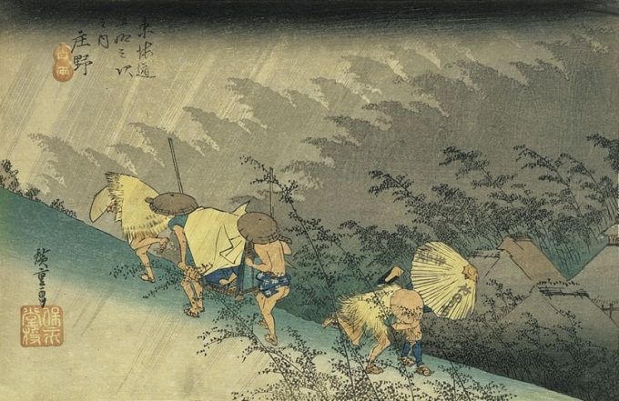

**Origami**

*Origami* is Japanese paper folding. In ancient times, Shinto shrines provided special paper for paper cutouts of human figures that were used in purification ceremonies. However, as paper became more widely available, origami also became an entertainment, which is its main purpose in Japan today. The paper is rarely cut, only folded. Origami's other uses include wrapping for gifts and folding traditional ornaments.

**Dolls**

Dolls have a very ancient history in Japan and many styles have developed over the centuries. The first dolls were probably prehistoric clay and stone figurines with religious or magic significance. Wooden dolls as playthings seem to have been popular in the Heian period (AD 794–1185) and other sorts of dolls were used in Shinto ceremonies at the emperor's court during the twelfth and thirteenth centuries. Dolls dressed as samurai or court ladies are still popular today.

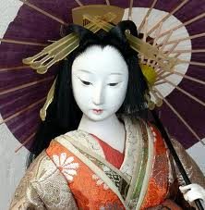 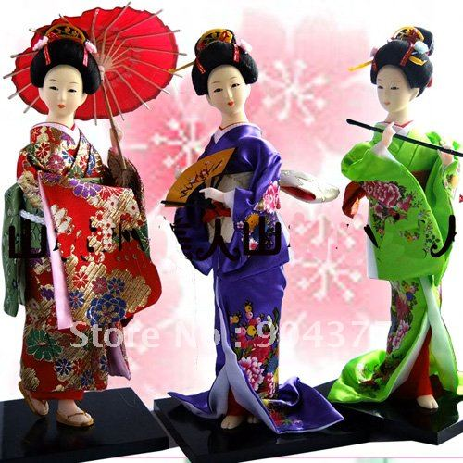 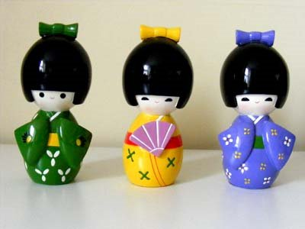

**Kites**

Kites are another Japanese art form associated with religion. It is possible that they originated in ancient times as a way of making offerings to the gods or sending prayers to heaven. There are also stories about them being used for sending messages in time of war. By the late Middle Ages, kites decorated with dragons, warriors and Chinese lions were flown for fun. Kite battles became a popular form of public entertainment.

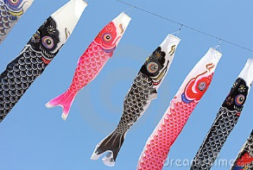 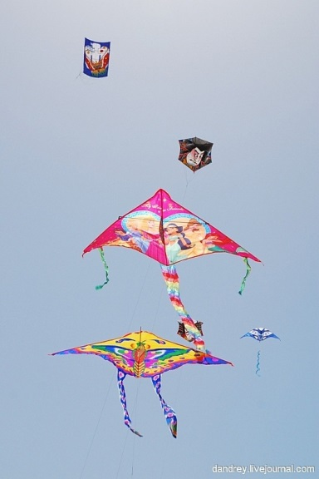 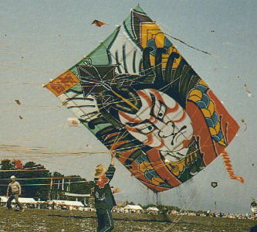

**Bonsai**

*Bonsai* or ‘tray planting’ came to Japan from China around 800 years ago, about the same time as Zen, and has continued in Japan over many centuries. Bonsai trees as old as 700 or 800 years still exist. They are grown in small pots or shallow ceramic trays and ideally look as natural as possible. Techniques of trimming roots and branches keep the trees between one-thirtieth and one-sixtieth of their natural size

