Senior Studies Ancient History
Assessment Task 1
Due date 3rd June 2015, Recess.
Topics
Part A – Sparta – 12.5 Marks
Part B – Cities of Vesuvius – 12.5 Marks
- You must provide a response to both Part A and Part B.
- Responses should be around 300 words (typed – A4) or one and a half pages (handwritten A4) in length.
- You responses should follow a mini essay format with an introduction, body and conclusion.
- You should include supporting evidence and a bibliography of any sources you use.
- Font size should be 11 or 12 and style should be academic (eg. times roman, Calibri)
__________________________________________________________
Syllabus outcomes:
H 1.1 describe and assess the significance of key people, groups, events, institutions,
societies and sites within their historical context
H 3.4 explain and evaluate differing perspectives and interpretations of the past
H 3.6 plan and present the findings of historical investigations, analysing and synthesising
information from a range of sources
H 4.1 use historical terms and concepts appropriately
_____________________________________________________________________________
Part A – Sparta

With reference to Source A and other sources of your own choosing, what does the evidence reveal about people’s lives in this period?

He [Lycurgus] even authorised them [the Spartans] to use other people’s household servants if anybody needed them. He also authorised hunting dogs to be shared, so that men who need some, ask to take them on their hunt, and the owner is pleased to send them if he is not at leisure himself.

Source A: Xenophon, Constitution of the Spartans PLUTARCH ON SPARTA translated with an introduction and notes by Richard J.A Talbert (Penguin Classics,1988). Translation, Introduction and Notes copyright © Richard J.A.Talbert, 1988. Reproduced by permission of Penguin Group Ltd.

Part B – Cities of Vesuvius
Using sources B, C and other sources of your choosing, what do they reveal about social classes in Pompeii and
Herculaneum?
Source B
Statue of Eumachia from Pompeii
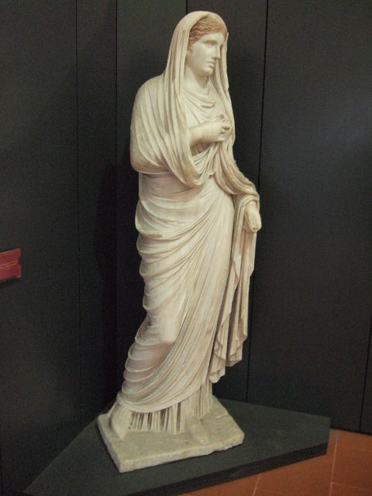

Source C

Tomb inscriptions outside the Herculaneum Gate

For Aulus Veius, son of Marcus, duumvir with judicial power, quinquennial duumvir for
the second time, military tribune by popular demand, by decree of the town council.

Marcia Aucta, his wife, made this tomb for Gaius Fabius Secundus and for herself and
for Fabia Gratina, daughter of Gaius, her daughter.

Naevoleia Tyche, freedwoman of Lucius, set this up for herself.

To Gnaeus Vibrius Saturninus, son of Quintus, of the tribe Falerna, his freedman
Callistus set it up.

From The Complete Pompeii by Joanne Berry
don. Reprinted kind permission of Thames and Hudson

MARKING GUIDELINES
Criteria | Marks
• Students respond in a sophisticated fashion addressing the included source and providing their own supporting evidence. They assess the significance of people and groups as related to the questions and are able to provide a range of perspectives and interpretations. Historical terms and concepts are used confidently. The response is handed in on time and in a neat, orderly fashion. | 21-25
• Students respond in a confident fashion addressing the included source and providing their own supporting evidence. They assess the significance of people and groups as related to the questions and are able to provide an alternative perspective and interpretation. Historical terms and concepts are used. The response is handed in on time and in a neat, orderly fashion. | 16-20
• Students respond with some thought addressing the included source but with limited supporting evidence. They attempt to assess the significance of people and groups as related to the questions with a basic understanding of perspectives and interpretations. Historical terms and concepts are used in a limited manner. The response is handed in on time and in a neat, orderly fashion. | 11-15
• Students respond in a limited way and fail to address the included source and do not provide any supporting evidence. They assess the significance of people and groups in a limited manner as related to the questions and are able to provide a range of perspectives and interpretations. Historical terms and concepts are not used. The response is handed in on time and in a neat, orderly fashion. | 6-10
• Students fail respond to the question and does not address the included source or provide their own supporting evidence. They assess the significance of people and groups as related to the questions in a very limited way, if at all. Historical terms and concepts are not used. | 1-5

